**Academic Credential Verification Using Blockchain**

**Progress Report**

*Submitted in the partial fulfilment for the award of the degree of*

**BACHELOR OF ENGINEERING**

**IN**

**INFORMATION SECURITY**

**Submitted by:**

**Prakash Singh**

**20BCS3707**

**Under the Supervision of:**

**Er. SHAGUN RANA**

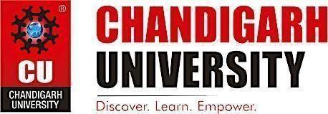

**CHANDIGARH UNIVERSITY, GHARUAN, MOHALI - 140413,**

**PUNJAB**

**NOVEMBER 2022**

**DECLARATION**

I, **‘PRAKASH SINGH’** student of **‘Bachelor of Engineering in Computer Science with specialization in Information Security**, **session: 2020-2024**, Department of Computer Scienceand Engineering, Apex Institute of Technology, Chandigarh University, Punjab, hereby declare that the work presented in this Project Work entitled **“Academic Credential Verification using Blockchain”** is the outcome of our own bona fide work and is correct to the best of our knowledge and this work has been undertaken taking care of Engineering Ethics. It contains no material previously published or written by another person nor material which has been accepted for the award of any other degree or diploma of the university or other institute of higher learning, except where due acknowledgment has been made in the text.

**Date: 4/11/2022 PRAKASH** **SINGH**

**Place: Chandigarh University, Mohali, Candidate UID: 20BCS3707**

**Punjab**

**ABSTRACT**

Blockchain is a revolutionary technology and will have great positive effects in our business environment in the near future. Blockchain technology significantly contributes to the verification process of academic qualifications since, by design, is resistant to modification of the data it holds. Blockchain is an open, distributed ledger that can record transactions of a community efficiently and in a verifiable and permanent way. In the context of academic qualifications, it can be assumed that: an academic qualification is a public transaction between an Institution and an individual, some stakeholders need to access these transactions, and each transaction cannot be modified once executed. These assumptions in conjunction with the decentralized nature of blockchain and the non-necessity of a trusted authority make blockchain an attractive solution. This project presents the conceptual design of an application that aims to verify academic credentials exploiting the Ethereum Blockchain. Similar applications have been proposed in literature but appear to have high implementation and maintenance costs. advantages of the proposed approach are integrity of stored data, decentralized data storage, instantaneous verification, low development and maintenance cost, and user-friendly interface. The project discusses the potential benefits through two use cases: for fraud detection and study mobility.

**Keywords: – Ethereum Blockchain, verification, fraud detection, Smart Contract.**

**ACKNOWLEDGEMENT**

I would like to thank my supervisor, Ms Shagun Rana, for his guidance and advice through each stage of making this project. I would also like to thank Mr Kushagra Agrawal sir for giving me this opportunity to work on a minor project in which I can show our true potential, creativity, and hard work. I would also like to thank my family and friends, who have been a constant support and have always motivated me to work hard and bring out the best in me. This project’s success and end necessitated a great deal of direction and assistance from many people, and we are extremely fortunate to have received it all as part of the project's completion. I owe everything we've accomplished to their oversight and help, and we'd like to express our gratitude.

**TIMELINE/GANTT CHART**

**Table of Contents**

|  |  |
| --- | --- |
| **SR.NO** | **PAGE NUMBER** |

|  |  |  |
| --- | --- | --- |
| 0 | Title page | 1 |
|  | Declaration of the Student | 2 |
|  | Abstract | 3 |
|  |  |
|  | Acknowledgement | 4 |
|  |  |
|  | Timeline / Gantt Chart | 5 |
|  |  |
|  |  |  |
| 1 | **INTRODUCTION\*** | 7 |
|  | 1.1 Problem Definition | 7 |
|  | 1.2 Project Definition  1.2.1 Existing System  1.2.2 Proposed System | 7  8  8 |
|  |  |
|  | 1.3 Blockchain and Smart Contract |  |
|  |  |
|  | 1.4 Hardware & Software Specification | 8 |
|  | 9 |
|  |  |
|  |  | 10 |
|  |  |  |
|  |  |
|  |  |  |
| 2 | **APPLICATION** | 13 |
|  |  |  |
| 3 | **LITERATURE SURVEY** | 16 |
|  |  |  |
| 4 | **PROBLEM FORMULATION** | 23 |
|  |  |  |
| 5 | **METHODOLOGY** | 24 |
|  |  |  |
| 6 | **OBJECTIVES** | 26 |
|  |  |  |
| 7 | **RESULTS & DISCUSSION** | 27 |
|  |  |  |
| 8 | **CONCLUSION & FUTURE WORK** | 28 |
|  |  |  |
| 9 | **REFERENCES** | 30 |
| 10 | **CODE & OUTPUT** | 30 |
|  |  |

**1 INTRODUCTION**

1.1 Problem Definition

Blockchain innovation is a rising innovation and offer highlights like decentralized, straightforward and sealed information stockpiling. It could be utilized to tackle issues for instance like absence of trust, misrepresentation, high exchange cost and sharing security Consequently, blockchain innovation may be a hopeful innovation to forestall the misrepresentation exercise in our present academic credential verification system which includes a lot of paperwork, forged degrees or degree from fake universities, delay admission processes and human error.

“Academic credential verification using Blockchain” focuses on automating the process of checking the authenticity and integrity of the academic credential that have been issued by the University in an optimal and efficient way. it allows the recruiters to verify the credentials of job applicant faster by removing the third party (University) and thus reducing the time delay and making the verification process much more efficient. This will lead to a smooth credential verification and solve the problem of fake academic credential in order to get a job or admission in a university.

**1.2 Project Definition**

Forgery of documents is a growing problem and demands the utmost attention. The fraudulent reproduction of certificates has increased significantly in recent years. Fake certificates and misrepresentation of facts are affecting industry, especially the IT sector, which recruits people in large numbers.

Depending on whether the hiring is permanent or contractual, there are different procedures for background verification. For a permanent hire, the client undertakes the responsibility of background checks whereas, in case of temporary staff, companies conduct stringent verification through associates.

This is very time taking process. This problem can be solved using a decentralised system.

DApps are built on a decentralized network that is supported by a blockchain distributed ledger. The use of blockchain enables a dApp to process data through distributed networks and to execute transaction

**EXISTING SYSTEM**

In the existing system, there is no digitalized way to verify the certificate. Although there are some universities that store certificates in digital form but are also in a centralized network where there is a chance of tampering the certificate. This may increase the cases of fraud since there is no means of security and integrity of the data both in manual and in digital form. The main reasons behind this problem are the lack of timestamp facility and method of storing data at a central storage. The employers verify the students’ credentials using third party lot of money and time consuming too.

**PROPOSED SYSTEM**

In this proposed system, we provide a platform to store and verify the student credentials using blockchain technology. With the help of the unique certificate ID, student can verify the certificate and also the company can verify whether the certificate provided by the student is authorized or not.

As the blockchain is distributed in nature and is popularly known as a distributed ledger, it is not easy to tamper the data stored in a block. The modules of the system are college, student and company. The main features of the project are enrolling the student and uploading the certificate onto the blockchain, both of which are done by college authorities. Students can view their certificates by logging in to their account.

Companies can view the certificates by sending an access request to students whose certificate they want to access. Once the student accepts the access request, company can view that particular student’s credential.

**1.4 Blockchain and Smart Contract**

Blockchain is a type of shared database that differs from a typical database in the way that it stores information. Blockchains store data in blocks that are then linked together via cryptography. As new data comes in, it is entered into a fresh block. Once the block is filled with data, it is chained onto the previous block, which makes the data chained together in chronological order. Different types of information can be stored on a blockchain, but the most common use so far has been as a ledger for transactions. In Bitcoin8s case, blockchain is used in a decentralized way so that no single person or group has control4rather, all users collectively retain control. With blockchain, banks also have the opportunity to exchange funds between institutions more quickly and securely. In the stock trading business, for example, the settlement and clearing process can take up to three days (or longer, if trading internationally), meaning that the money and shares are frozen for that period of time.

Smart contracts are simply programs stored on a blockchain that run when predetermined conditions are met. They typically are used to automate the execution of an agreement so that all participants can be immediately certain of the outcome, without any intermediary's involvement or time loss. the smart contract can be programmed by a developer – although increasingly, organizations that use blockchain for business provide templates, web interfaces, and other online tools to simplify structuring smart contracts.

**1.6 Hardware Specification**

PC/Laptop: - A PC is a personal computer that can be used for multiple purposes

depending on its size, capabilities, and price. They are to be operated directly by the

end user.

Personal computers are single-user systems and are portable. This makes it feasible for individual use.

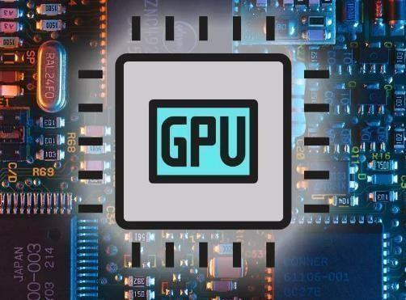

1.6 Software Specification

**Visual Studio Code**

Visual Studio Code is a code editor redefined and optimized for building and debugging modern web and cloud applications.

**React**

React is a free and open-source front-end JavaScript library for building user interfaces based on UI components.

**Metamask:**

MetaMask is a free web and mobile crypto wallet that allows users to store and swap cryptocurrencies, interact with the Ethereum blockchain ecosystem, and host a growing array of decentralized applications (dApps)

**Ganache:** Ganache is a private Ethereum blockchain environment that allows to you emulate the Ethereum blockchain so that you can interact with smart contracts in your own private blockchain

**Remix IDE**

Remix is a powerful, open source tool that helps you write Solidity contracts straight from the browser. Written in JavaScript, Remix supports both usage in the browser and locally. Remix also supports testing, debugging and deploying of smart contracts

**Solidity:**

Solidity is an advanced programming language used for implementing Ethereum-based smart contracts. It's an object-oriented language that targets the Ethereum virtual machine (EVM).

**APPLICATION**

Academic Credential verification using Blockchain concept have a wide range of applications. Some of the applications are:

2.1 Snapcert.io: SnapCert enables secure digitization, generation, authentication, sharing, and verification of any kind of academic certificates and creates value for the entire ecosystem through the Trust as a Service.

2.2 Consensys: Build next-generation apps, launch blockchain-based financial infrastructure, and access the decentralized web with ConsenSys' Ethereum product suite.

2.3 Exonum: A blockchain-based system can serve as a verification clearinghouse for these documents by providing public and private proof of the veracity of a document.

2.4 Blockcerts: Build apps that issue and verify blockchain-based records for academic credentials, professional certifications, workforce development, and civic records

13

**3 Literature Survey**

This research is done by Krishnan, Kumutha & S., Jeyalaksshmi. (2021). Blockchain Technology and Academic Certificate Authenticity-Review. Blockchain technology has the abilities that are Decentralized, Distributed, Secure and Faster, Transparent, and non-modifiable. These are more beneficial than the existing technologies. For students, educational certificates are the most important documents issued by their universities. However, as the issuing process is not that transparent and verifiable, fake certificates can be easily created. Blockchain technology has recently emerged as a potential mean for authenticating the document verification process and a significant tool to struggle document fraud and misuse. This research aimed to enhance the document verification process using blockchain technology

This research is done by Michoulis, George & Petridou, Sophia & Vergidis, Kostas & Michoulis, George. (2020). Verification of Academic Qualifications through Ethereum Blockchain: An Introduction to VerDe. Blockchain technology significantly contributes to the verification process of academic qualifications since, by design, is resistant to modification of the data it holds. Blockchain is an open, distributed ledger that can record transactions of a community efficiently and in a verifiable and permanent way. In the context of academic qualifications, it can be assumed that: an academic qualification is a public transaction between an Institution and an individual, some stakeholders need to access these transactions, and, each transaction cannot be modified once executed. These assumptions in conjunction with the decentralized nature of blockchain and the nonnecessity of a trusted authority make blockchain an attractive solution. This paper presents the conceptual design of VerDe, an application that aims to verify academic qualifications exploiting the Ethereum Blockchain. Similar applications have been proposed in literature but appear to have high implementation and maintenance costs.

This research is done by Krishnan, Kumutha & Jayalakshmi, S (2021). The Impact of the Blockchain on Academic Certificate Verification System-Review. Blockchain innovation guarantees benefits in believe capacity, collaboration, organization, identifying proof, validity, and transparency. These solid suggestions for the long run of how to verify the authenticity of academic certificates because a paper-based certification is fallible to manipulation and susceptible to fraud.. This paper proposes a digital certificate verification blockchain based system employing anowner authentication scheme and time, space of the students are stored as blocks using blockchain technology. A distributed public record with tamper proof and immutable that preserves the state of the document, which creates security in the digital asset. This clearly stated that this technology is required to keep digital assets in secure and any one can access without loss of data and maintained it with minimum cost.

This Research is done by Badhe, Vipul & Nhavale, Pooja & Todkar, Sonal & Shinde, Prajakta & Kolhar, Kiran. While the number of universities, tertiary education students and number of graduates per year constantly increase, the need to easily verify degree certificates generates new business opportunities Students demand a proof-of-certification at low cost and easy to check, employers also demand quick and trustable verification of degrees when recruiting. As large number of students graduate every year, the problem of fake certificates is a big issue. One can easily get fake certificates in India. Companies hiring thousands of fresher spend large amount of money to get the educational certificates and transcripts verified of applicants. A Digital Certificate using blockchain technology can address this problem. Blockchain is a decentralized distributed digital ledger collectively maintained by a network of computers, called nodes. The data in the blockchain cannot be modified by a person without the consent of everyone else who maintains the records. This makes the data secure.

This Research is done by hakan, Yassynzhan & Kumalakov, Bolatzhan & Mutanov, Galimkair & Mamykova, Zhanl & Kistaubayev, Ye.I.. (2021). Verification of University Student and Graduate Data using Blockchain Technology. Blockchain is a reliable and innovative technology that harnesses education and training through digital technologies. Nonetheless, it has been still an issue keeping track of student/graduate academic achievement and blockchain access rights management. Furthermore, academic achievement documents issued by institutions are not secured against unauthorized changes due to the involvement of intermediaries. Therefore, verification of official educational documents has become a pressing issue owing to the recent development of digital technologies. However, effective tools to accelerate the verification are rare as the process takes time. This study provides a prototype of the UniverCert platform based on a consortium version of the decentralized, open-source Ethereum blockchain technology. The proposed platform is based on a globally distributed peer-to-peer network that allows educational institutions to partner with the blockchain network, track student data, verify academic performance, and share documents with other stakeholders.

**PROBLEM FORMULATION**

Education acts as a soul in the overall societal development, in one way or the other. Aspirants, who gain their degrees genuinely, will help society with their knowledge and skills. But, on the other side of the coin, the problem of fake certificates is alarming and worrying. It has been prevalent in different forms from paper-based dummy certificates to replicas backed with database tampering and has increased to astronomic levels in this digital era. The proposed system makes sure that the certificates, once verified, can be present online in an immutable form for further reference and provides a tamper-proof concealment to the existing certification system. To confirm the credibility of the proposed method, a prototype of blockchain-based credential securing, and verification system is developed in Ethereum test network. The implementation and test results show that it is a secure and feasible solution to online credential management system.

**METHODOLOGY**

6.1 Front-end: It will contain six to seven different pages. First, of all there will be a welcome page with upload certificate form followed by the verification and publish certificate .

Languages used:

6.1.1 ReactJS 

6.1.2 Tailwind CSS

6.1.3 web3.js

6.2 Back-end:

Steps for designing the backend of website –

6.2.1 Create certificate

6.2.2 view certificate 

6.2.3 verify cerificate

Languages used:

Solidity

Ganache-cli

Remix IDE

24

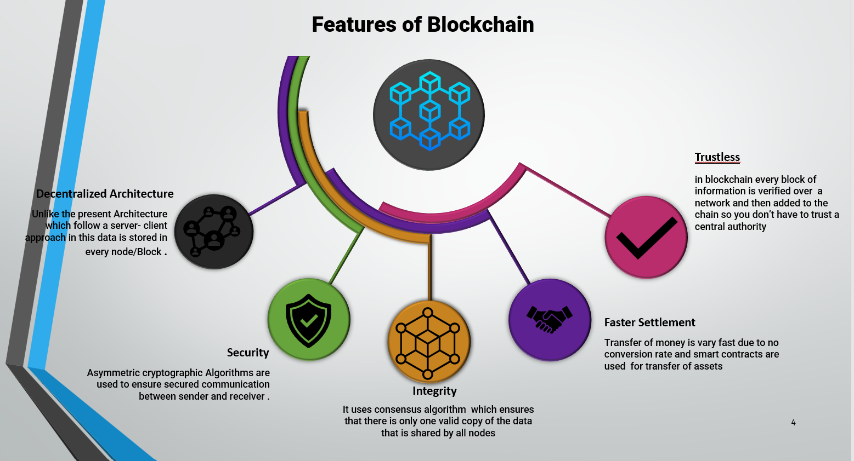

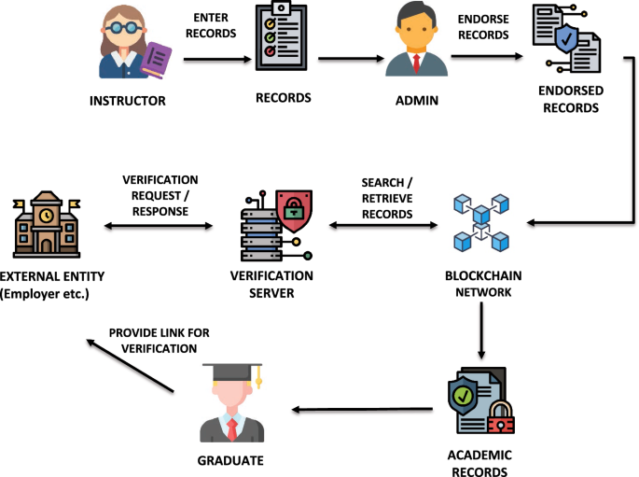





1. **OBJECTIVES**

The proposed work is aimed to carry out work leading to the development of automating the process of verification by exploiting the immutable properties of Blockchain . The proposed aim will be achieved by dividing the work into following objectives:

1. Giving colleges to publish certificate.
2. The students share the certificate-id to employers
3. Employers can verify the credentials on blockchain.

26

1. **RESULTS & DISCUSSION**

The problem of manual authentication of each credential can be solved by saving the Blockchain encrypted academic credentials The Blockchain platform makes transactions unchangeable and openly verifiable; these Blockchain properties are used to produce digital certificates that are flawless and simple to check. We have developed a web portal which is linked to the Blockchain that stores the academic credentials of all the students who have graduated from the University. The potential employer/ educational institute can access a web portal designed by us to verify all details of the students after providing necessary credentials given to them by the student. With the help of our applications. The digital certificates are stored on an Ethereum Blockchain. Our solution is scalable, and because of the use of Blockchain, it provides immutability. As the backend is handled by the AWS, we do not have to worry about the overhead costs. This makes maintenance costs cheaper significantly. We have tabulated the cost of some operations, which helped us to come to the conclusion that the Ethereum Blockchain is highly cost-effective in comparison to other Blockchain Systems

Benefits

• **No third-party involvement**: This methodology would prevent the participation of the third party in the process of validation of academic credentials.

**• The portal is accessible 24 / 7**: Since this will be an online portal, it will be readily available to the authorised users whenever and wherever required.

**• Robust data security**: Since the system uses blockchain technology, it ensures high transparency, offering a more secure network to store students' private data. Any change made to the data is easily traceable, thus minimising risk to forgery of data.

• **Environmentally Safe**: Since the whole system will be digitalised, it will help in saving paper and time, thus contributing to environmental sustainability.

. • Putting back the trust in education: When institutions merge with other bodies or there is war or other natural calamities, the academic data will be safe and protected.

• **No more fake certificates:** There will be no more morphed certificates as certificates will be digitally verified.

• **Multiple verifications at once:** Multiple certificates are verified once at the time.

1. **CONCLUSION & FUTURE WORK**

The resulted web application based on the blockchain technology will furthermore corelate with other existing educational application this will solve the problem of the forged certificate, manual authentication of each record and create the process much more efficient by saving weeks of time and paperwork. For analysts, blockchain can possibly be trying to concentrate all the more intently on subjects like identity management, document management, certificate verification, health care, insurance, e-voting, supply chain management, property management etc. While physical anti-counterfeiting features prevent tampering chances, digital solutions help in intelligence and identifying culprits in the systems as well as facilitating fast and convenient authentication. Many Universities are now using digital track and trace solutions. Prospective employer/ university professionals can check the authenticity of the degree through scanning these QR codes. However the application of blockchain technology in education domain are more beneficial but still this research topic is in exploratory phase and the proceeding of blockchain standards and regulations is necessary to expand its use in this education domain

While physical anti-counterfeiting features prevent tampering chances, digital solutions help in intelligence and identifying culprits in the systems as well as facilitating fast and convenient authentication. Many Universities are now using digital track and trace solutions. Prospective employer/ university professionals can check the authenticity of the degree through scanning these QR codes. However, the application of blockchain technology in education domain are more beneficial but still this research topic is in exploratory phase and the proceeding of blockchain standards and regulations is necessary to expand its use in this education domain

1. **References**

* Professor Kumutha.K and Dr. S. Jayalakshmi “Blockchain Technology and Academic Certificate Authenticity-Review” in *2021 ICOECAIN Bangalore*
* EURASIP journal on Information Security 2021, Article number 7 by Rama Reddy, T., Prasad Reddy, P.V.G.D., Srinivas, R.
* “Blockchain-Based Academic Certificate Verification System—A Review” conference paper by Shivani Pathak, Vimal Gupta, Nitima Malsa, Ankush Ghosh & R. N. Shaw.
* Michoulis, George & Petridou, Sophia & Vergidis, Kostas & Michoulis, George. Verification of Academic Qualifications through Ethereum Blockchain:

1. **OUTPUT**

**Navbar**





